**Uncovering The Gaming Industry’s Hidden Gems:**

**A Comprehensive Analysis of Video Game Sales**

**A Project Report**

Submitted by

P. PRABHAVATHI 222000971

K. PRIYADHARSHINI 222000972

S. POONGODI 222000970

S. PAVITHRA 222000969

**CONTENTS**

|  |  |  |
| --- | --- | --- |
| **CHAPTER NO** | **TOPIC** | **PAGE NO** |
| **1** | **Introduction** |  |
| **2** | **Problem Defining & Design Thinking** |  |
| **3** | **Data collection & extraction from Database in MYSQL** |  |
| **4** | **Introduction to Tableau** |  |
| **5** | **Connecting Database and Tableau** |  |
| **6** | **Data Visualization** |  |
| **7** | **Dashboard and stories** |  |
| **8** | **Web Integration** |  |
| **9** | **Advantages and Disadvantages** |  |
| **10** | **Conclusion & future Scope** |  |

**1.INTRODUCTION:**

Video game sales analysis is the process of collecting and analyzing data about the sales of video games in order to understand market trends and consumer behavior.

This type of analysis can be useful for a variety of purposes, including identifying the most popular games and genres, predicting future sales, and developing marketing strategies.

Video game sales analysis typically involves collecting data from kaggle sources. It was generated by a scrape of vgchartz.com. This data may include information about the number of units sold, the retail price, and the platforms on which the games are played. Once the data has been collected, it is typically analyzed using tableau.

Analysing sales data from more than 16,500 games. This dataset contains a list of video games with sales greater than 100,000 copies. It was generated by a scrape of vgchartz.com.

Video game sales analysis may be conducted by game developers, publishers, retailers, and other industry professionals. It is an important part of the video game industry, as it helps to understand the needs and preferences of consumers and to identify opportunities for growth and innovation.

**Technical Architecture:**

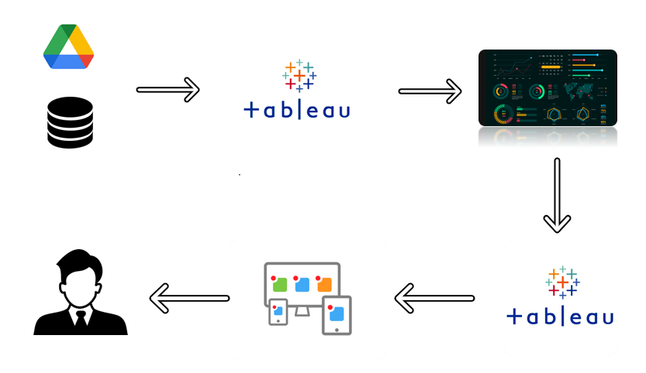

**PROBLEM DEFINING & DESIGN THINKING**

**EMPATHY MAP:**

The empathy map, one of Gamestorming’s methods for understanding audiences, including users, customers, and other players in any business ecosystem.

Start by drawing a circle to represent the person and give the circle a name and some identifying information such as a job title. It helps if you can think of a real person who roughly fits the profile, so you can keep them in mind as you proceed. In keeping with the idea of a “profile” think of the circle as the profile of a person’s head and fill in some details. You might want to add eyes, mouth, nose, ears, and maybe glasses if appropriate or a hairstyle to differentiate the person from other profiles you might want to create. These simple details are not a frivolous addition — they will help you project yourself into the experience of that person, which is the point of the exercise.

**Empathy Map Canvas:**

[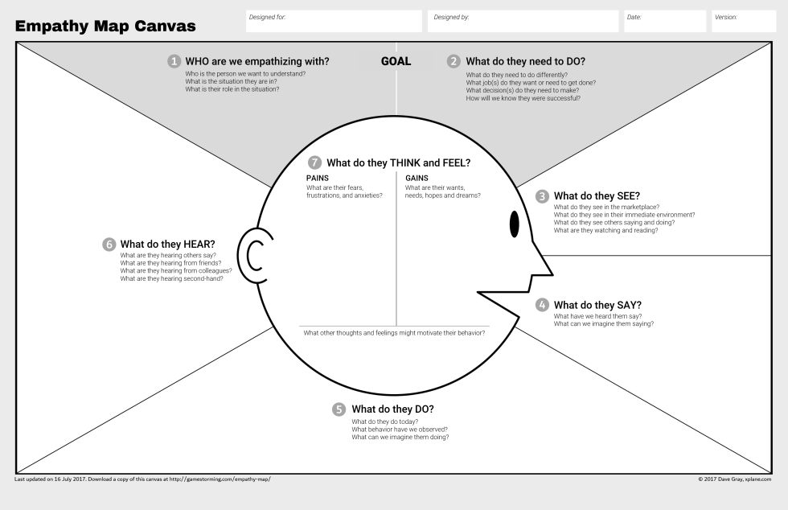](https://gamestorming.com/update-to-the-empathy-map/empathy-map-006-png/)

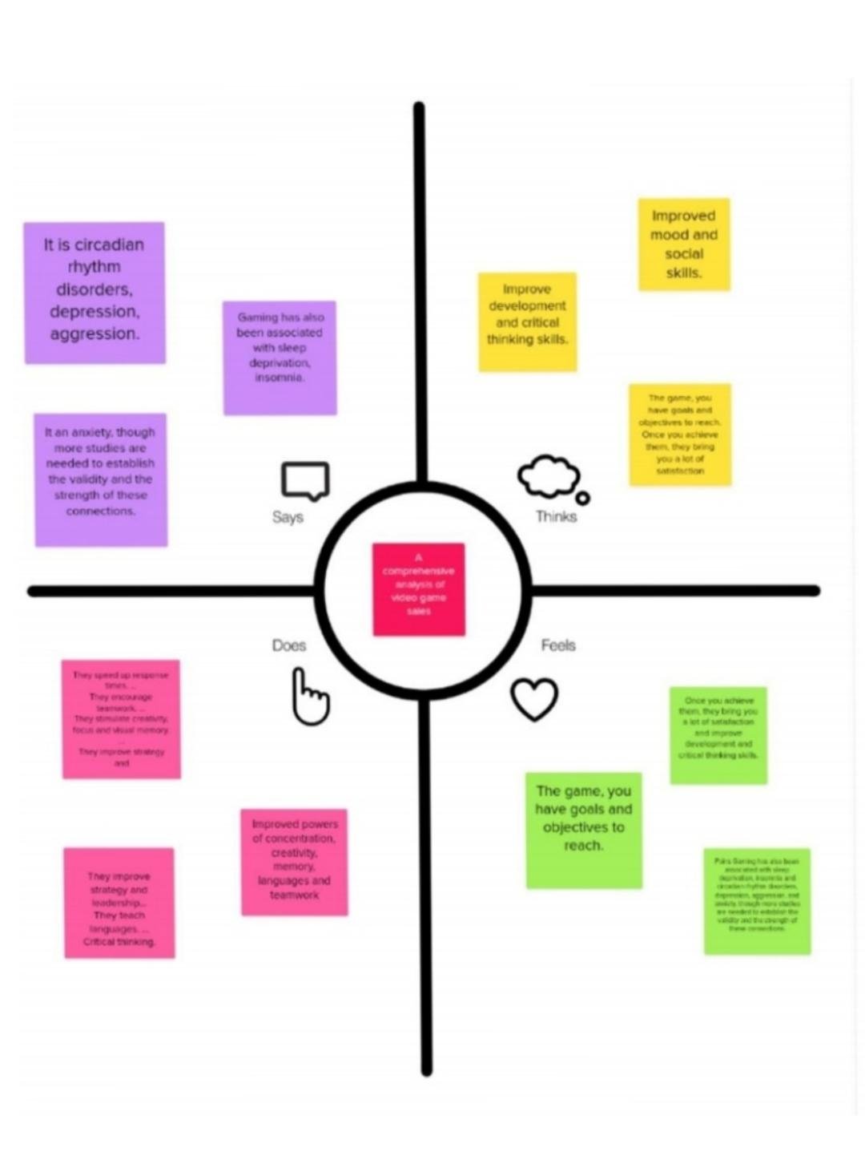**Empathy Map:**

**IDEATION & BRAINSTORMING MAP:**

* Brainstorming is **the process of generating as many ideas as possible in a short amount of time without regard for organization**. Afterward, a tool like an idea map is used to organize those thoughts and show the relationship between different ideas.
* The main idea behind the ideate step in design thinking process is to generate ideas and try to segregate them into categories. This helps in brainstorming without judgment, helps in bringing all the ideas to the table and helps proceed to the next step called ‘Prototyping’, where the ideas are checked for their The feasibility and value.
* Mind map is a diagram that helps to observe and study information in a visual manner. Mind map is created around a single problem statement and all the ideas to solve the problem are written around it. The problem statement usually is written at the center of a blank page as a hub and branches shoot out in all directions representing the solutions.
* The ideas can be represented as text, images, trees, and even smaller mind maps. The entire map looks like a top view of a tree, with the problem statement as the trunk and the solutions as branches.

**BRAINSTROMNG MAP:**

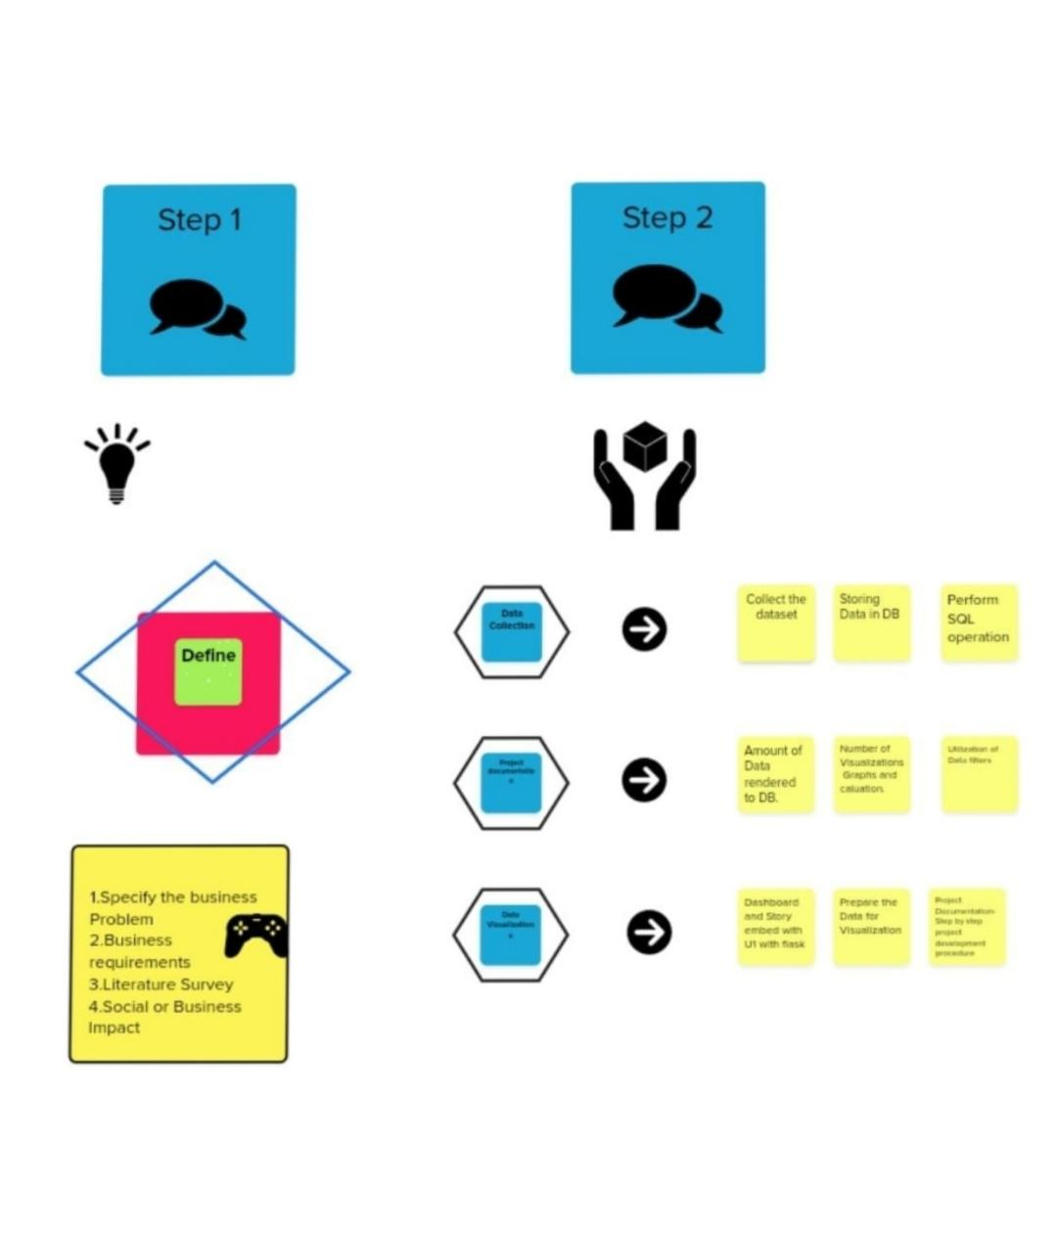

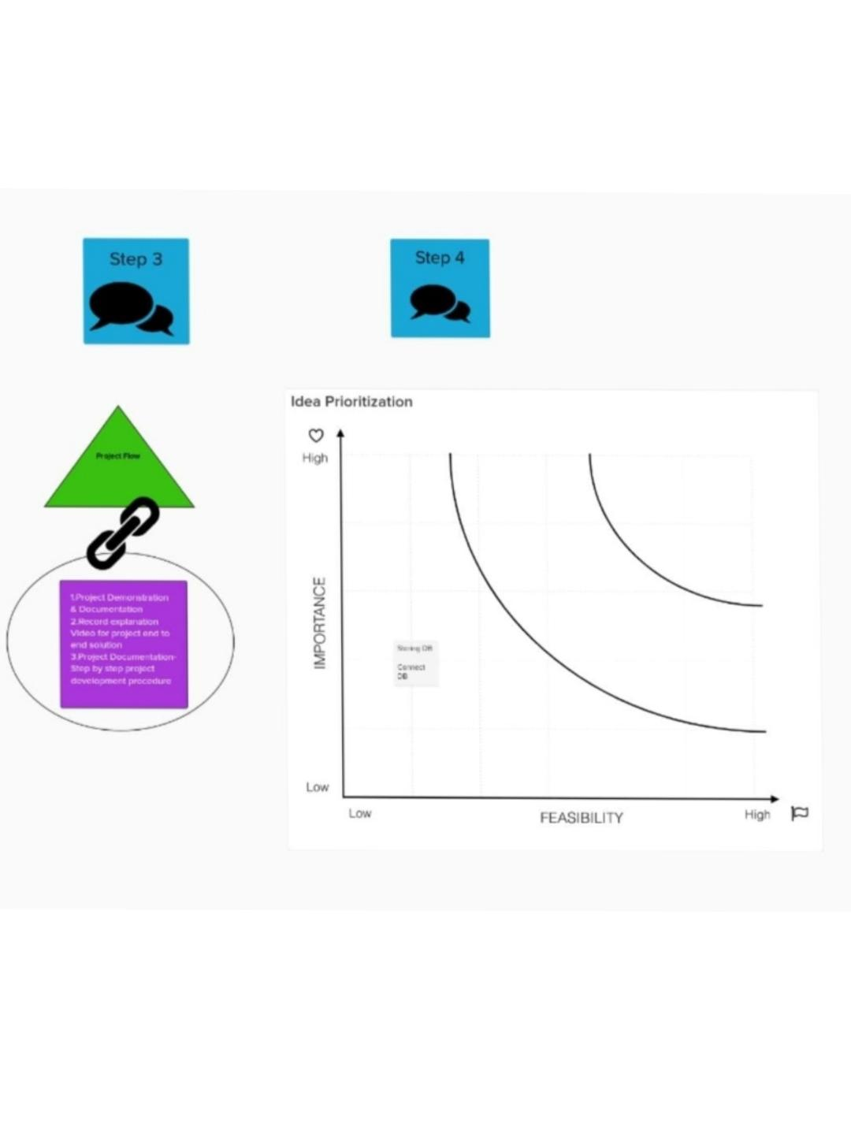



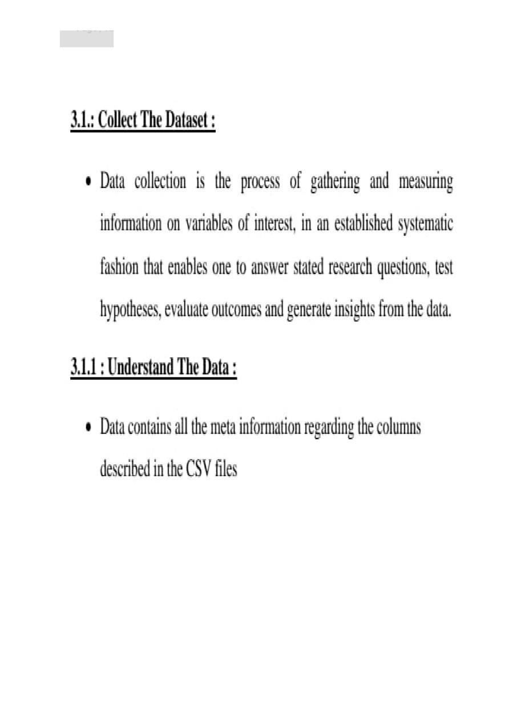

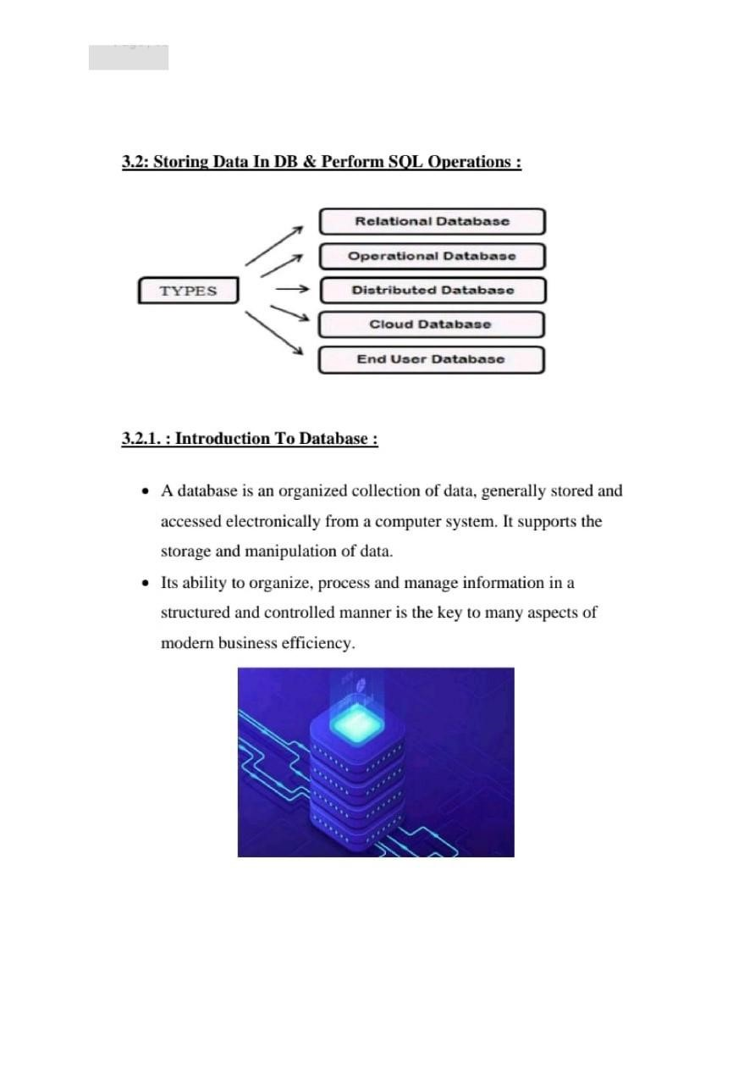

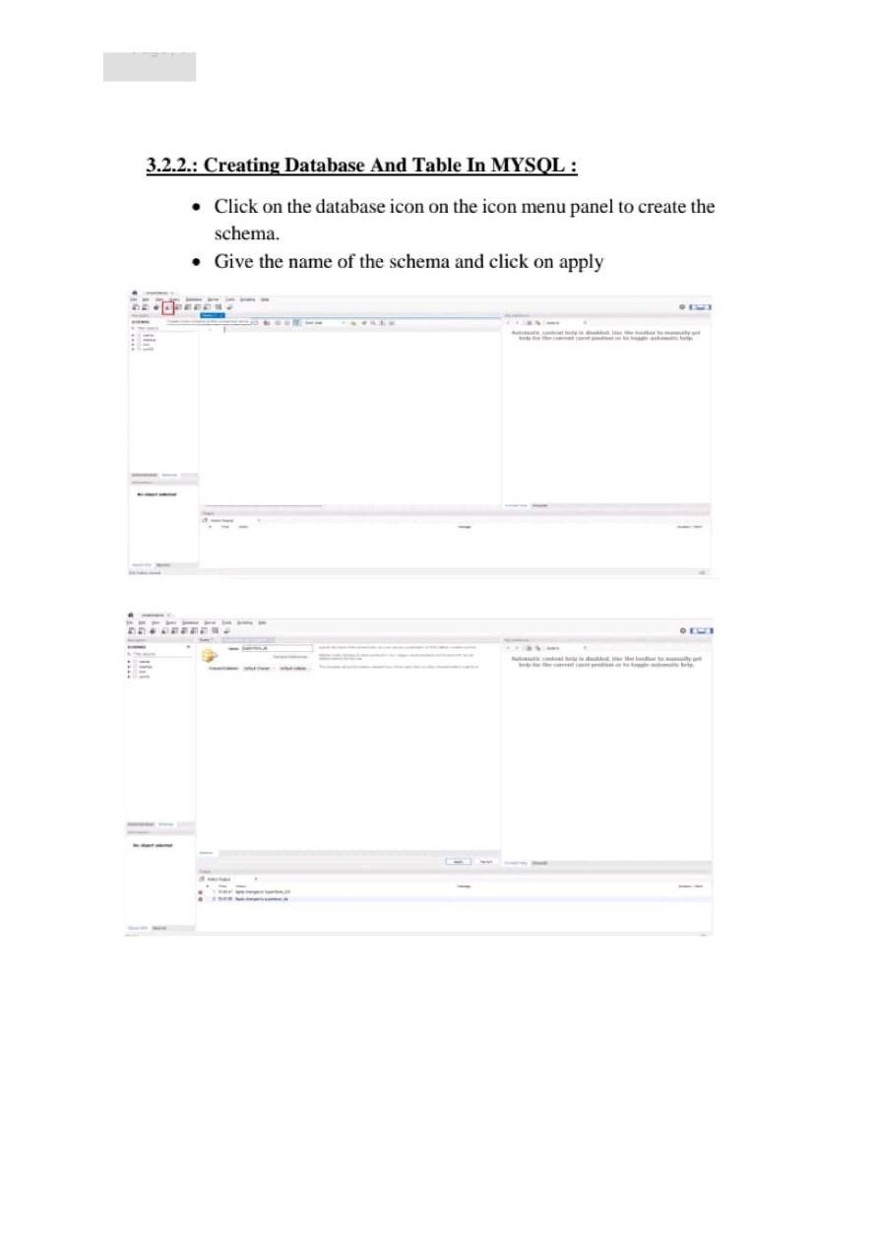

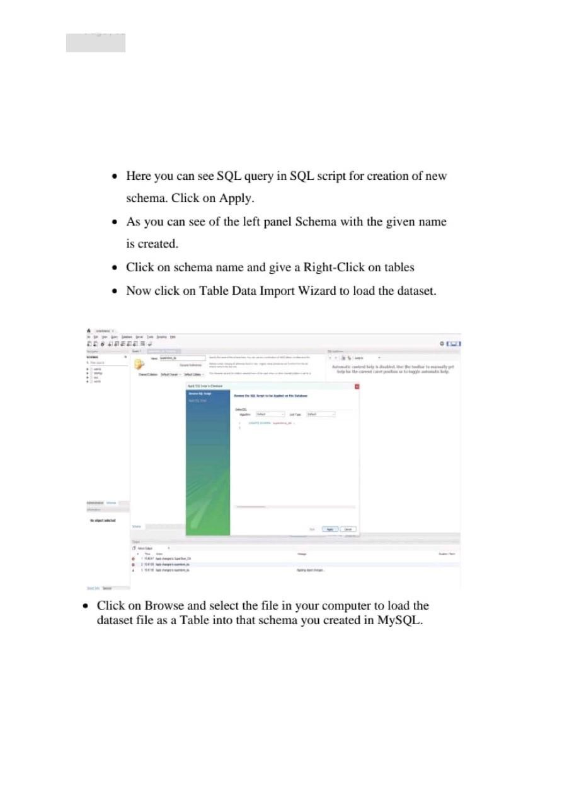

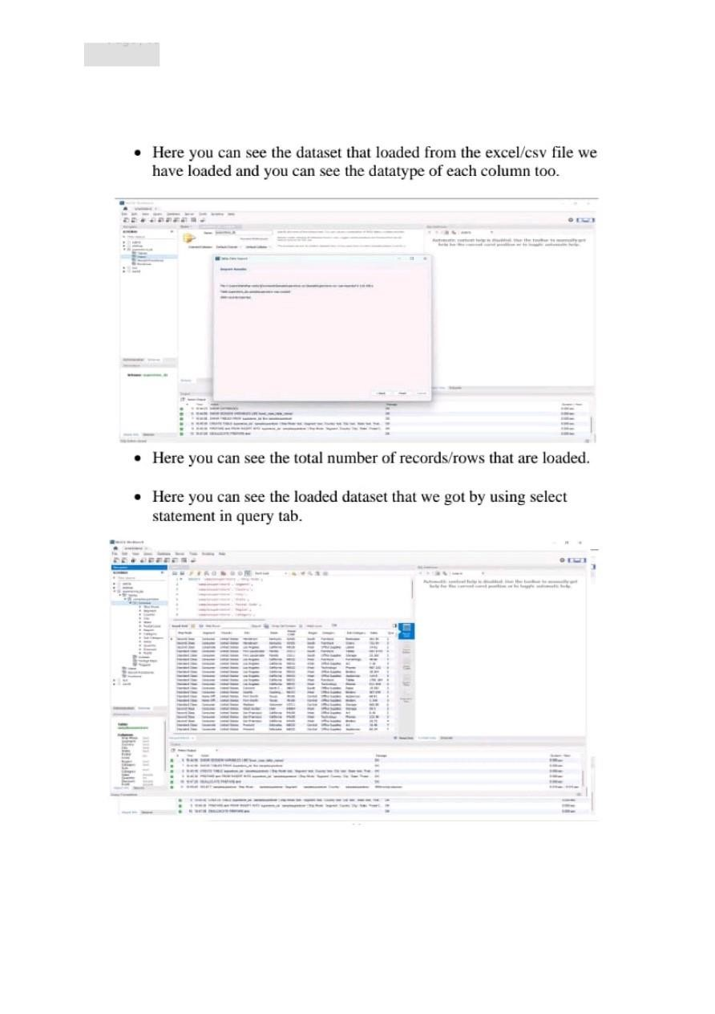

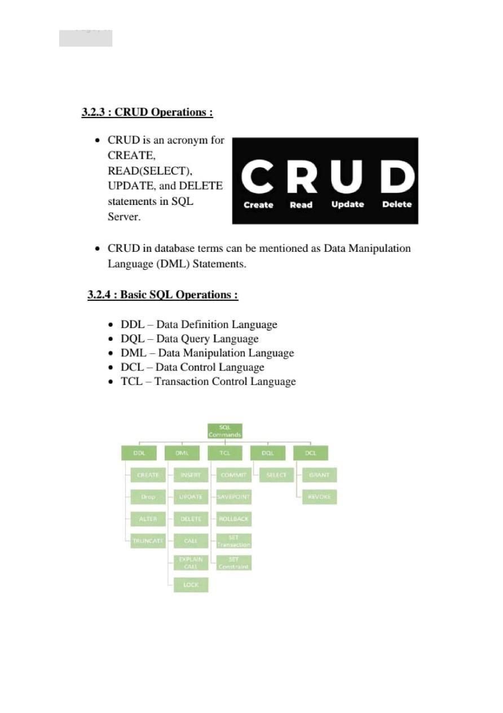



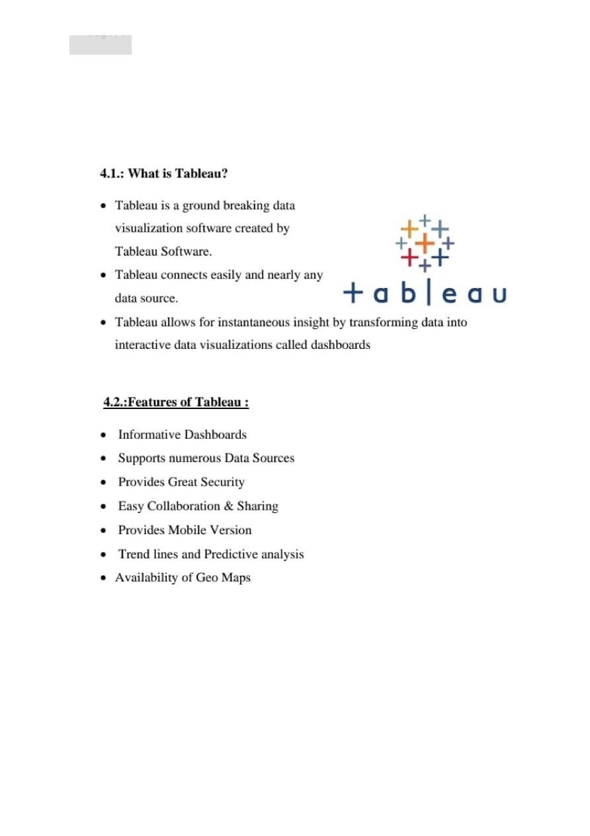

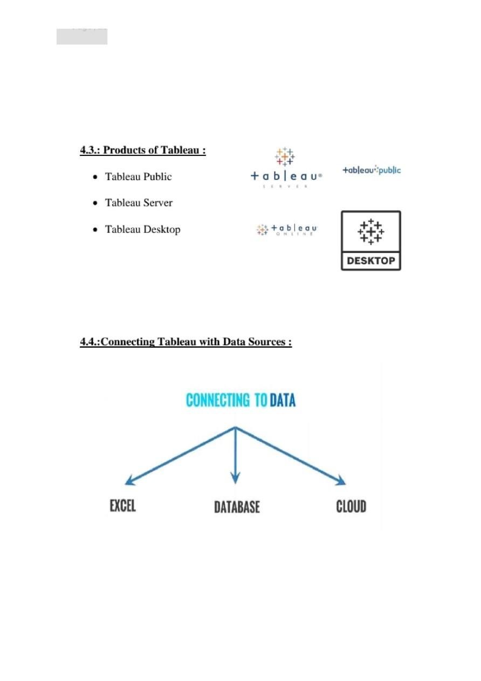

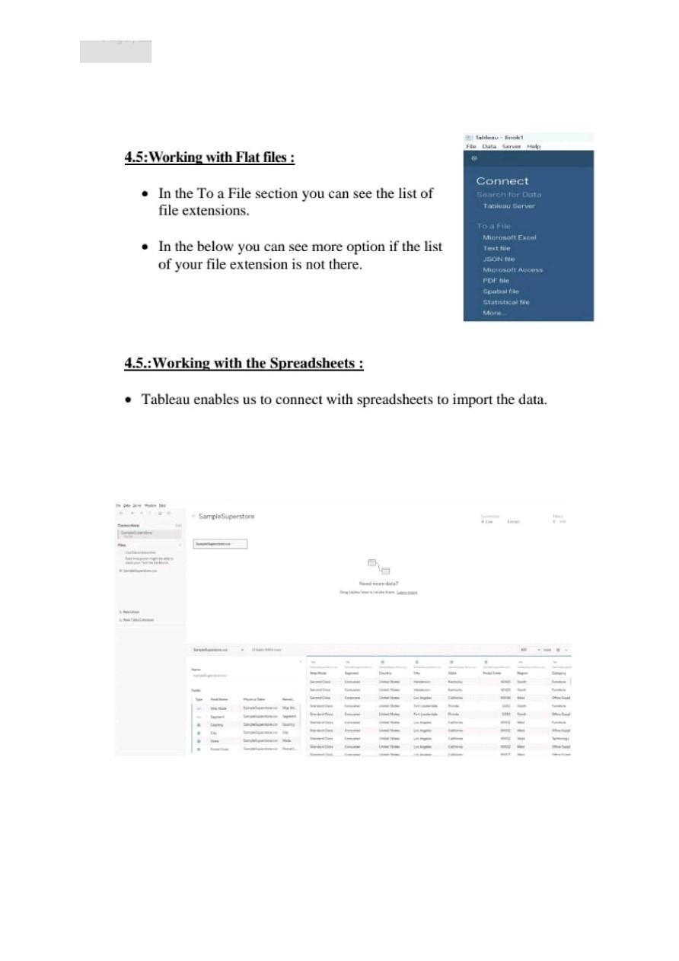

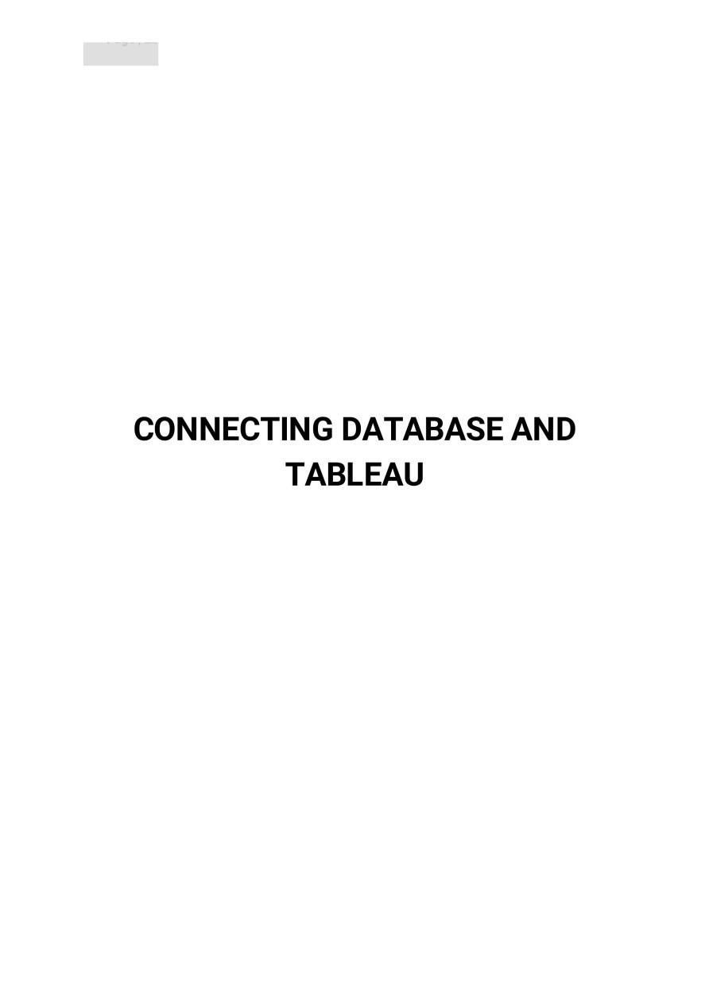



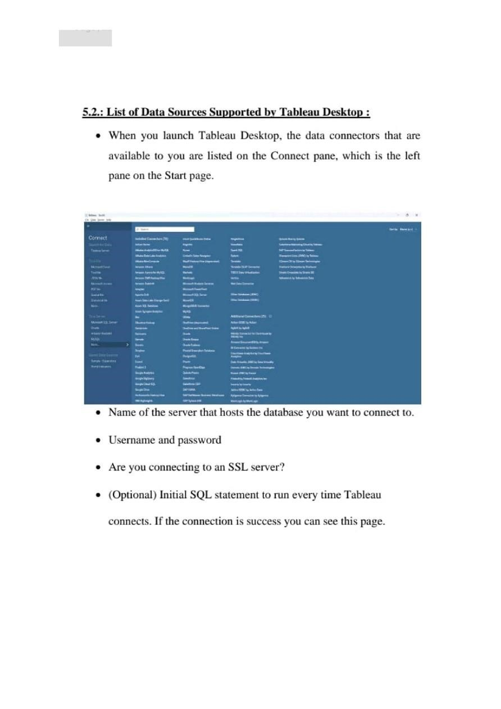

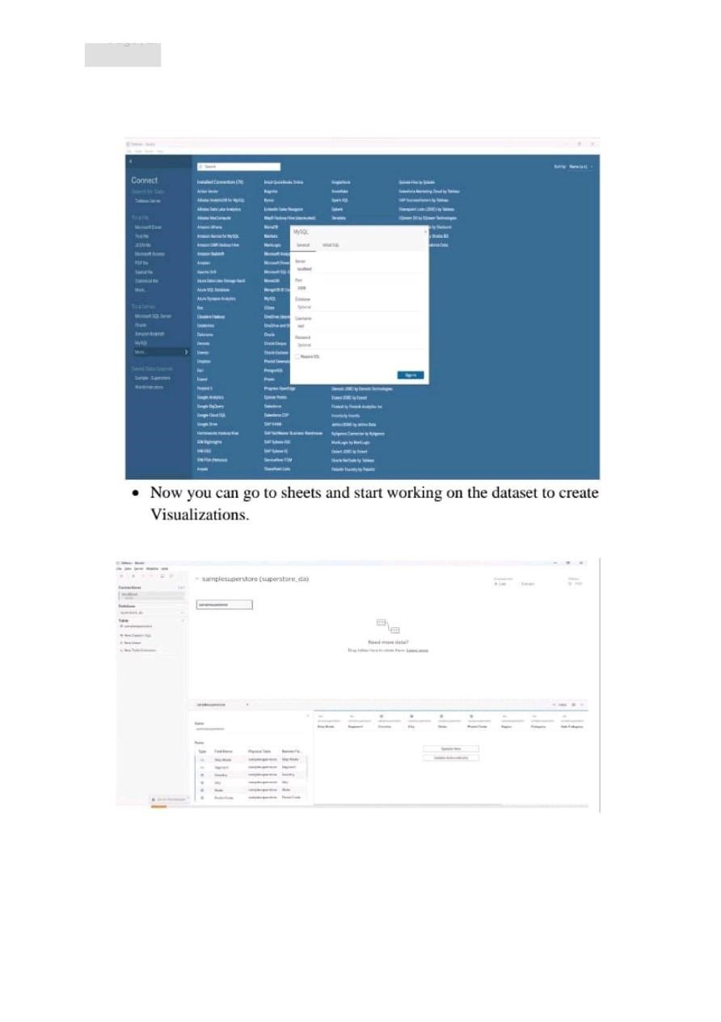



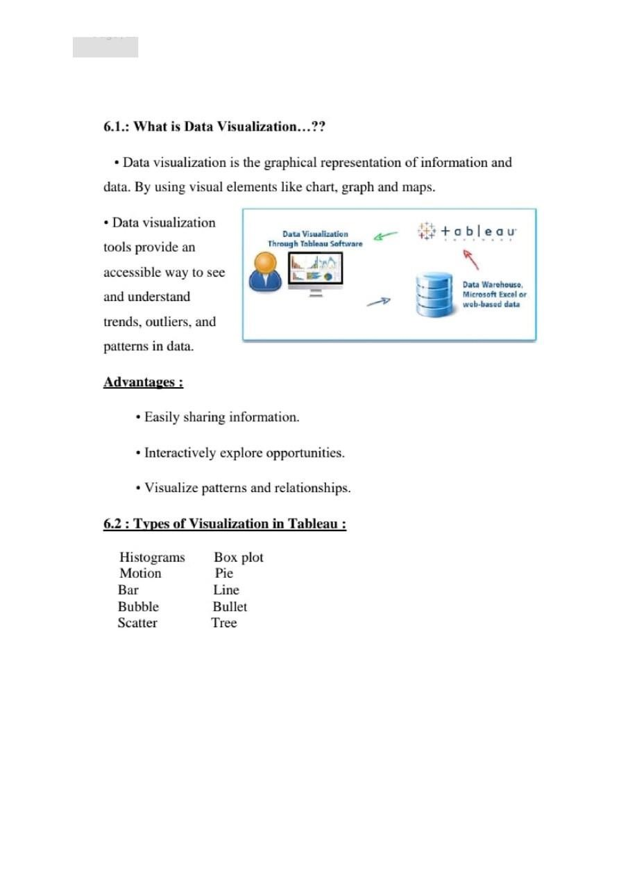

**DASHBOARD AND STORIES**

**DASHBOARD:**

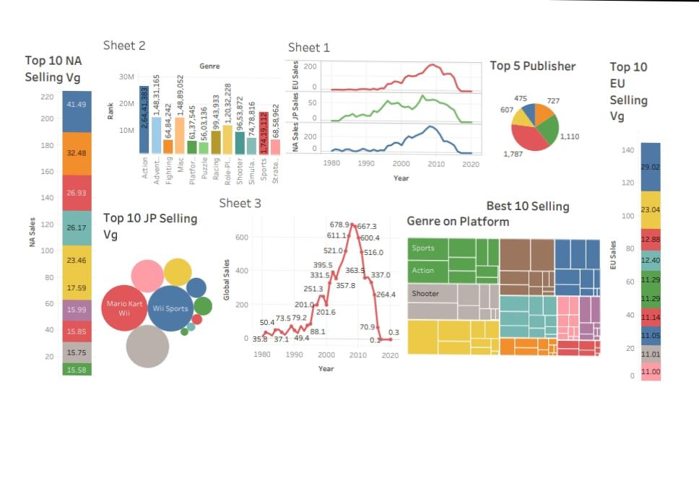**STORIES:**

